|  |
| --- |
| US Department of Labor  office of labor-management standards |
| LM-1 Electronic Form |
| Functional Requirements |
| Release v1.0 |
|  |

**Revision History**

|  |  |  |  |
| --- | --- | --- | --- |
| **Date** | **Revision** | **Description** | **Author** |
| **07/01/2019** | **1.0** | **Initial Draft** | **Bineeta Adityan** |
| **11/25/2019** | **1.1** | **Added requirements for the Approval process.** | **Bineeta Adityan** |
|  |  |  |  |

**Contents**

1. Background 1

2. Project Description 1

3. Purpose 1

3.1. Definitions, Acronyms, Abbreviations 1

3.2. References 2

4. FUNCTIONAL REQUIREMENTS 2

4.1. Login 2

4.1.1. Registration Requirements 2

4.1.1.1. User Registration 2

4.1.1.2. LM-1 Registration 2

4.1.1.2.1. Generate Registration ID and PIN 2

4.2. Page-Level Requirements 6

4.2.1. Page 1 6

4.2.1.1. Business Requirements 6

4.2.1.2. Functional Requirements 6

4.2.1.3. Header Section 6

4.2.1.4. Footer Section 6

4.2.1.5. Design 6

4.2.1.6. Requirements 8

4.2.1.7. Section/Field Level Requirements 9

4.2.2. Page 2 14

4.2.2.1. Business Requirements 14

4.2.2.2. Functional Requirements 14

4.2.2.3. Header Section 14

4.2.2.4. Footer Section 14

4.2.2.5. Design 14

4.2.2.6. Requirements 14

4.2.2.7. Section/Field Level Requirements 15

4.2.3. Page 3 17

4.2.3.1. Business Requirements 17

4.2.3.2. Functional Requirements 17

4.2.3.3. Header Section 17

4.2.3.4. Footer Section 17

4.2.3.5. Design 18

4.2.3.6. Requirements 18

4.2.3.7. Section/Field Level Requirements 19

4.2.4. Page 4 21

4.2.4.1. Business Requirements 21

4.2.4.2. Functional Requirements 21

4.2.4.3. Header Section 21

4.2.4.4. Footer Section 21

4.2.4.5. Design 21

4.2.4.6. Section/Field Level Requirements 22

4.2.5. Page 5 23

4.2.5.1. Business Requirements 23

4.2.5.2. Functional Requirements 23

4.2.5.3. Header Section 24

4.2.5.4. Footer Section 24

4.2.5.5. Design 24

4.2.5.6. Requirements 24

4.2.6. Validation Summary Page 25

4.2.7. Other functionalities 25

4.2.7.1. Save 25

4.2.7.2. Add Attachments 25

4.2.7.3. Validate 25

4.2.7.4. Print 25

4.2.7.5. Help 26

4.2.7.6. Form Instructions 26

4.2.8. Submit 26

4.2.8.1. EFS Submission Confirmation Message 26

4.2.8.2. Email Confirmation 27

4.2.8.3. Email generated to the OLMS approver’s team 28

4.2.8.4. Email text for an Affiliated or an Unaffiliated organization 28

4.2.8.5. Email text for a National Organization 29

4.2.9. Approval Process 30

4.2.9.1. Approval Email Notifications to the filers 30

4.2.9.2. Disclosed Report 30

4.3. Login using rejected LM-1 31

4.4. Amend an LM-1 form 31

Requirements Revisions History 32

# Background

Every labor organization subject to the Labor-Management Reporting and Disclosure Act (LMRDA) and the Civil Service Reform Act (CSRA) standards of conduct regulations require to adopt a constitution and bylaws and file two copies together with an initial Form LM-1 with OLMS. The initial Form LM-1 must report certain information concerning the structure, practices, and procedures of the labor organization.

OLMS will acknowledge receipt of the organization’s initial Form LM-1 and provide a 6-digit identifying file number that has been assigned to the organization. This file number is required for filing the annual financial reports.

A labor organization is required to file an amended Form LM-1 to update the information on file with OLMS if there are any changes in the practices and procedures listed in Item 18, Column (2) of its most recent Form LM-1.

# Project Description

The Electronic Forms System (EFS) is the Office of Labor-Management Standards’ (OLMS) web-based system for completing and submitting labor organization and other reports. Currently, the EFS system is available for submitting most of the LM forms. The goal for the management is to make the system available to all other annual reports to help reduce the number of paper submissions.

# Purpose

The purpose of this project is to create the electronic version of the LM-1 report. Electronic LM-1s will be available via the EFS system.

# Definitions, Acronyms, Abbreviations

The following is a list of commonly used acronyms used throughout this document:

| Term | Definition |
| --- | --- |
| DIS | Division of Interpretations and Standards |
| DOL | Department of Labor |
| e.LORS | Electronic Labor Organizations and Reports System |
| EFS | Electronic Filing System |
| Filer | Users who prepare and sign the form |
| FRD | Functional Requirements Document |
| HTML link | HyperText Markup Language link |
| LM | Labor Management |
| LMRDA | Labor-Management Reporting and Disclosure Act |
| OLMS | Office of Labor-Management and Standards |
| OMB | Office of Management and Budget |
| Preparer | Users who prepare the form |
| PIN | Private Identification Number |
| NHQ | National Headquarters |
| UNAFF | Unaffiliated |

# References

* LM-1 PDF form
* LM-1 Instructions document

# FUNCTIONAL REQUIREMENTS

* The preparer or filer shall register his/her user account in the EFS system to prepare and submit the LM-1 form.
* The filer or preparer shall be able to start a new form or access the in-progress forms.
* The system will have the field level and form level validation rules to authenticate the data before the submission.

# Login

The EFS system will have a link to navigate to the LM-1 user interface. The filer or preparer may create a new account or may use an already existing account to access the form.

# Registration Requirements

# User Registration

A filer or a preparer of the labor organization who has not registered in the EFS system shall register using the EFS user registration module.

For the detail requirements, refer Filer Registration Requirements document.

# LM-1 Registration

To access the electronic LM-1 form, the organization needs a Registration ID and a PIN.

# Generate Registration ID and PIN

The EFS system will provide the following link on the Main page to generate a Registration ID and PIN to access a new LM1.

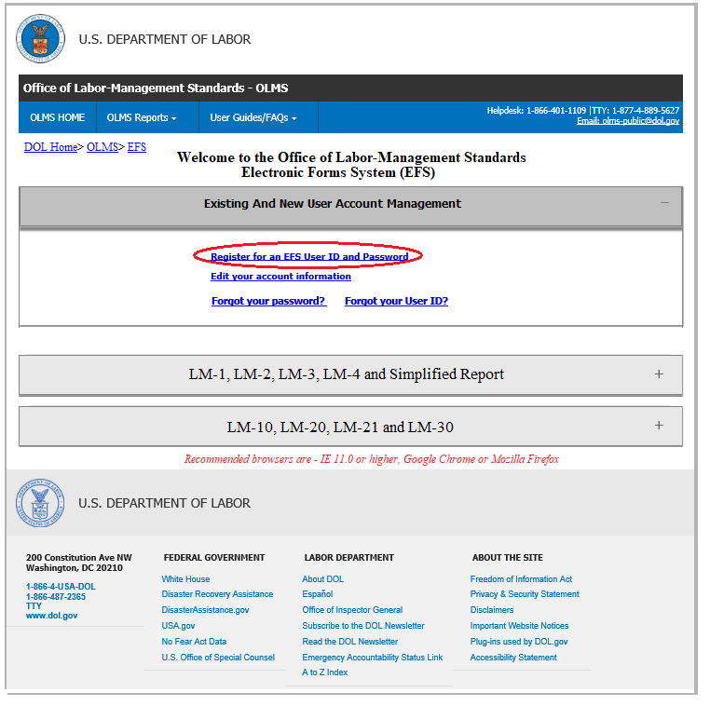

* The link ***Obtain an Initial LM-1 Registration ID and PIN*** will be added to the EFS home page.
* A filer will click the link to generate a unique Registration ID and a Union PIN for a labor organization.
  + **Registration ID**: The system will generate the registration ID in the format – ***one letter followed by six numbers***. The first ID will be **A00001**. The system will increment the number part when a new user generates a registration ID.
  + **Union PIN**: Unique identifier generated by the system

The screen will display the following message.

**Please save the Registration ID and Union PIN to file the LM-1 form. You will need to distribute this Registration ID and PIN to all users who prepare, sign, and/or file an LM-1 form for your organization.**

**To access your LM-1 form, please return to EFS log in page and enter the Registration ID and PIN.**

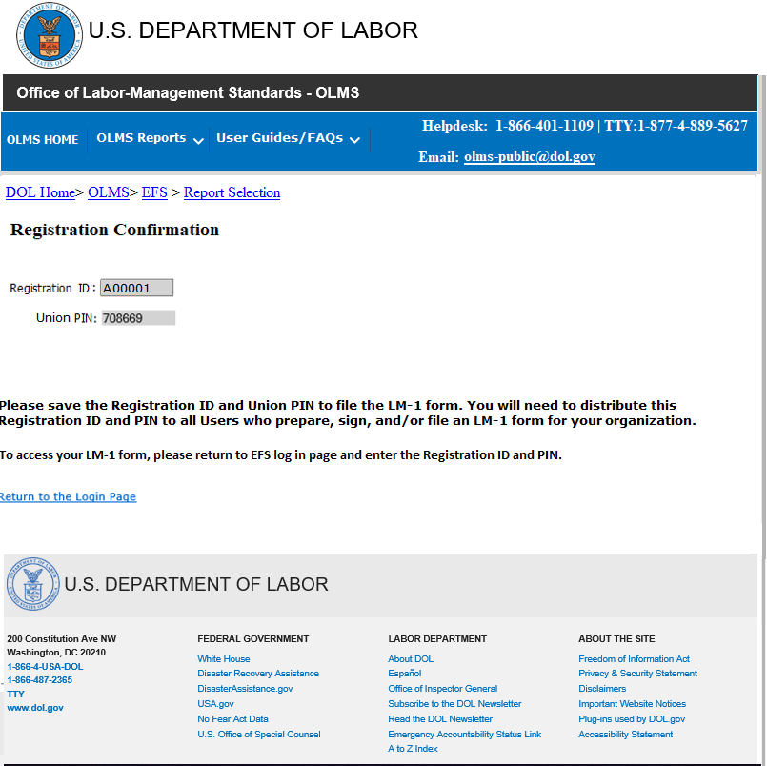

* + The EFS system will email the successfully generated registration ID and the PIN to the filer.

Email Subject line: LM-1 Registration Confirmation

Your Registration ID is **A00001** and a unique Private Identification Number (PIN) is **708669**.

Please save a copy of this email for future reference, as you will need to distribute this Registration ID and PIN to all users who prepare, sign, and/or file LM-1 form for your labor organization.

To log into the EFS, all your users must enter a valid user id and password, the Registration Id and the PIN.

 If you did not register this labor organization and believe you have received this email in error, please contact the EFS Helpdesk at 1-866-401-1109.

* The union officers will share this registration ID and PIN to access their LM-1 in progress to complete the form and to sign/submit the form.
* The system will not allow a user to generate a new registration ID and PIN until that LM-1 is successfully submitted.
* In case, if the filer tries to generate a new Registration ID and PIN the EFS system will display the following error message.

**Users can only be associated with one LM-1 Registration ID at a time. A Registration ID and PIN is already associated with your EFS account. If you forgot your Registration ID or PIN, or if you feel this is an error, please contact the OLMS help desk at (866) 401-1109.**

* The filer will return to the EFS home screen to login to the EFS system using the new Registration ID generated.
  + The filer will enter the user account, Registration ID and PIN in the following section.

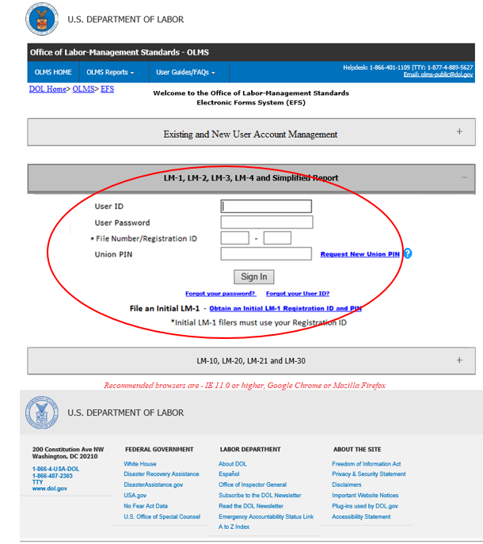

* Upon successful login, the system will navigate the filer straight to the LM-1 report.
* Multiple filers may use the same **Registration ID** and **PIN**.
* Any filers entering a valid **User Account, Registration ID** and **PIN** are allowed to access a new or in-progress LM-1 form of the Labor organization.
* After the successful submission of an LM-1 form, the **Registration ID** will not be accessible.

# Page-Level Requirements

Page-level requirements and the validation rules for each page are detailed throughout this document.

# Page 1

# Business Requirements

Page 1 captures the information about the reporting organization.

# Functional Requirements

The system shall display ‘Page 1’ in the following states.

* When the filer opens an LM-1 form.
* When the filer selects the “<” (PREVIOUS)’ button on PAGE 2 – item 10-17
* When the filer selects the ‘MAIN’ link from Left Navigation Panel

# Header Section

The header and footer items pictured below will be displayed on Page 1.

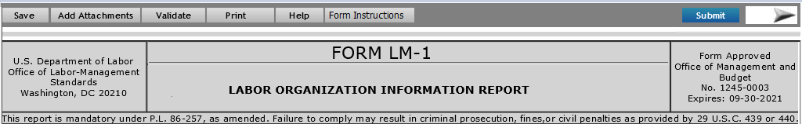

# Footer Section



# Design

A mock-up design for Page #1 is displayed below.

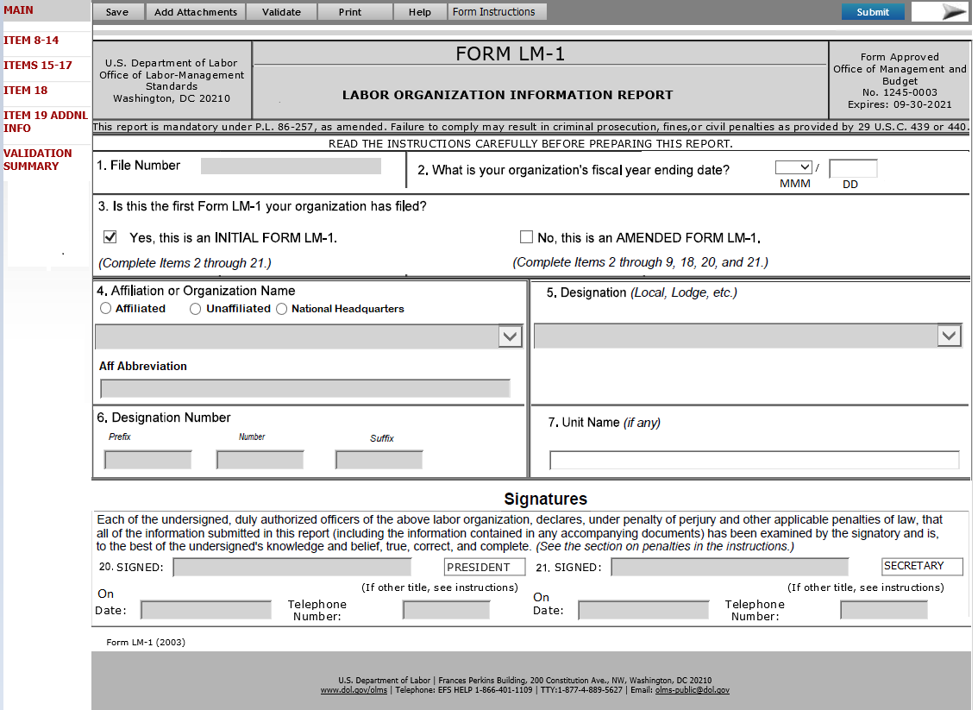

**New LM-1**

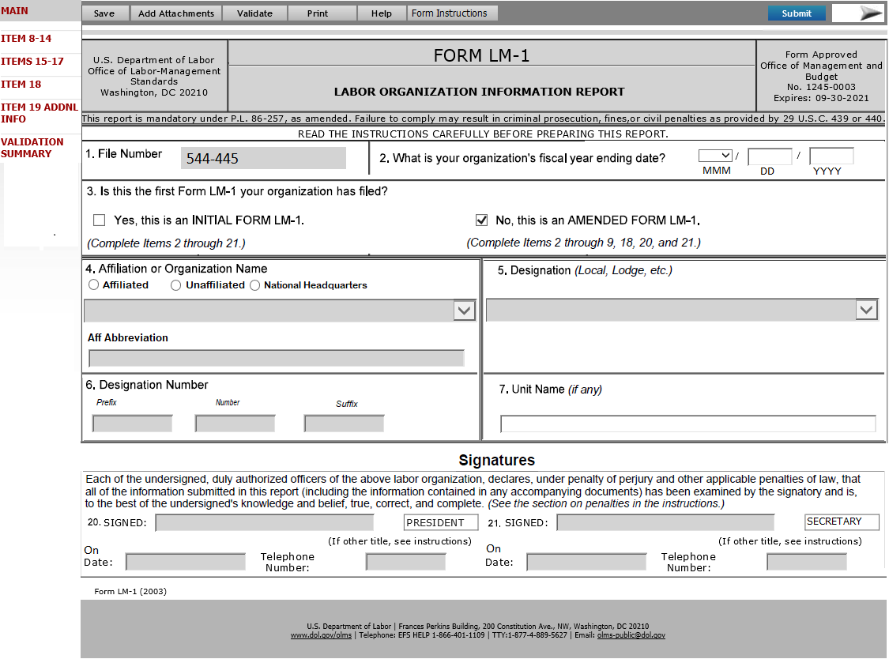

Amended LM-1

# Requirements

MAIN (Page #1) is the landing page. Items 1-7 along with the Signature section will be listed on this page.

The required fields are marked in the following screen mock-up.

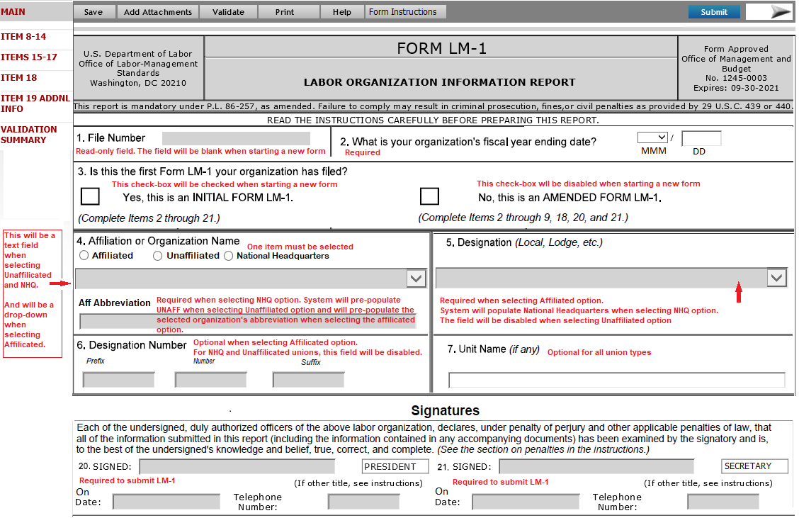

# Section/Field Level Requirements

* **1 –File number** – This field will be blank for a new LM-1.
  + Will display the file number of the organization when amending an LM-1 and will remain read-only.
* **2. What is your organization’s fiscal year ending date?** – The following requirements applied to this field:
  + For initial Form LM-1 – Month and Day fields will be listed as below:



* + For amended Form LM-1 – Three separate fields to capture the month, day and year will be listed. A Mock-up is listed below:



* + - The date can be in the past or future.
* **3.** **Is this the first From LM-1 your organization has field.** – Items listed in this section and the requirements are described below:
  + **Yes, this is an INITIAL FORM LM-1** – This will be a check-box field. This checkbox will be checked by the system when starting a new form and will remain as a read-only field.
  + **No, this is an AMENDED FORM LM-1** – This will be a check-box field. This checkbox will be checked by the system when amending a submitted form and will remain as a read-only field.
* **4. Affiliation or Organization Name. -** Items listed in this section and the requirements are described below:
  + This field will display the following hover text displayed.
* Select one of the three options based on which reflects the status of your union.  You must indicate the highest union in your union’s hierarchy in the entry field for this Item, but first you need to select the option that reflects where your union is within its union affiliation hierarchy.
  + This item should list three radio buttons: **Affiliated**, **Unaffiliated** and **National Headquarters**. Allowed to select only one option.

The following requirements apply when selecting each option.

* + **Affiliated** – Selecting this option should display the following pop-up message explaining the selected item.
* By selecting this option, you are indicating that your union is a local or intermediate union that is affiliated with a national parent union. Next, please select the name of your national-level parent union from the drop-down list.

The following fields will get enabled for the data entry at this time and the requirements for these fields listed below.

* + - **4 – Affiliation or Organization** – the system will enable this field as a **drop-down** list. All existing unions (Union_name) will be listed in this drop-down list.
    - **Aff Abbreviation** – Initially the field will be blank and will be read-only. When the filer picks the union_name from the drop-down list in **Item 4 – Affiliation or Organization**, the abbreviation for the selected union will automatically populate in this field. The field will remain read-only.
  + **Unaffiliated** - Selecting this option should display the following pop-up message explaining the selected item.
* By selecting this option, you are indicating that your union has no parent union or subordinate union(s). Next, please enter your union’s name in the text field (either full name or your standard abbreviation).

The following fields will get enabled for the data entry at this time and the requirements for these fields listed below.

* + - **4 – Affiliation or Organization** – the system will enable this field as a **text** field. The filer will enter the name of the union in this field.
    - **Aff Abbreviation** – System will automatically populate **UNAFF** in this field and will remain read-only.
  + **National Headquarters** - Selecting this option should display the following pop-up message explaining the selected item.
* By selecting this option, you are indicating that your union is itself the national-level parent to one or more subordinate unions and not subordinate to any other national-level union. Next, please enter your union’s name in the text field (either full name or your standard abbreviation).

The following fields will get enabled for the data entry at this time and the requirements for these fields listed below.

* + - **4 – Affiliation or Organization** – the system will enable this field as a **text** field. The filer will enter the name of the union in this field.
    - **Aff Abbreviation** – the system will enable this field as a **text** field. The filer will enter the union abbreviation in this field. The following data requirements will be applied.
      * Not allowed to enter an integer in this field.
    - If the user enters an integer, the following error will appear.

**Please use letters (A-Z) only.**

* + - * Not allowed using an existing union abbreviation.
    - When entering an existing abbreviation, the system will provide the following error message to the user to correct it.

**Another union is already using this abbreviation. Please select another abbreviation.**

* **5. Designation** **(*Local, Lodge, etc.)*** – Initially the field will be disabled. Based on the option selected in Item 4- (**Affiliated**, **Unaffiliated** and **National Headquarters)** this field will be enabled. The following requirements applied to this field.
  + If the **Affiliated** option is selected in Item 4, **Item 5 Designation** will be enabled as a drop-down list. All existing designations (except National Headquarters) will be listed in this drop-down list.
  + If the **Unaffiliated** option is selected in Item 4, **Item 5 Designation** will be disabled for the data entry.
  + If the **National Headquarters** option is selected in Item 4, **Item 5 Designation** will automatically be populated as ***National Headquarters*** and will remain read-only.
* **6. Designation Number** – the following three separate fields will be listed under this item. The system will enable these fields for data entry only when the option **Affiliated** is selected in Item 4. When **Unaffiliated** and **National Headquarters** options selected in Item 4, these fields remain disabled for the data entry.
  + **Prefix –** This will be a text field to enter the designation prefix.
  + **Number –** This will be an integer field to enter the designation number.
  + **Suffix –** This will be a text field to enter the designation suffix.
* **7. Unit Name (*if any****)* – This will be a text field to enter the unit name of the union. The field will be available for data entry for all union types. This field will display the following hover text.
* Please enter your union’s unique unit name here (e.g. Chicago Area Local), if applicable, such as if you are an affiliated intermediate or local that uses a name instead of or in addition to a designation number and already provided the name of your parent union in Item 4.
* **Signatures** – This section will be listed on page 1. The following requirements are applicable to this section
  + The signature section will be enabled only when the form validation completes without any errors.
  + Both the president and the treasurer, or the corresponding principal officers, of the reporting organization, must sign the completed Form LM-1.
  + **Submit** button will be enabled when successfully entering both signatures.

The field-level requirements in this section are listed below:

* **20. SIGNED & 21. SIGNED**- The system will list two **SIGNED** fields for getting two sets of signatures. Once the form is ready to sign, the system will enable these fields.

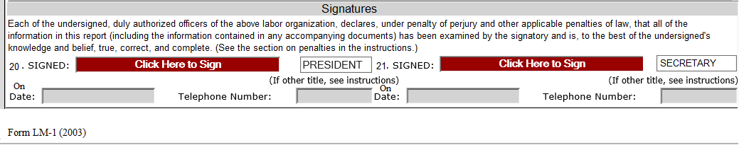

When the filer clicks on the field “**Click Here to Sign”** the following pop-up will be opened.

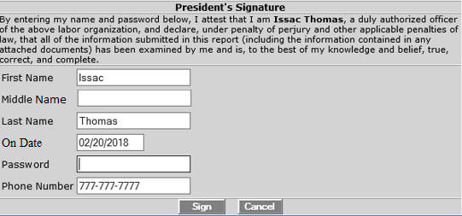

The pop-up will list the title of the filer on the header. The window will list the following disclaimer statement.

“**By entering my name and password below, I attest that I am <First Name Last Name>, a duly authorized officer of the above labor organization, and declare, under penalty of perjury and other applicable penalties of law, that all of the information submitted in this report (including the information contained in any attached documents) has been examined by me and is, to the best of my knowledge and belief, true, correct, and complete.”**

The following fields will be listed in this pop-up window. The filer should be able to modify any information listed in this pop-up.

* **First Name** – The field will list the first name of the filer. The filer should be able to modify this field before signing the form.
* **Middle Name** – The field will list the middle name of the filer. The filer should be able to modify this field before signing the form.
* **Last Name** – The field will list the last name of the filer. The filer should be able to modify this field before signing the form.
* **On Date** – The field will list the current date in DD/MM/YYYY format. The filer should be able to modify this field before signing the form.
* **Password** – The field will capture the password for the account which the filer used while login to the LM-1 form.
* **Phone Number** - The field will list the structurally valid U.S. Telephone numbers (including area code). The filer should be able to modify this field before signing the form
* **Sign** – If the filer has entered the valid password, clicking this button will sign the form. If a wrong password is entered, the system will give a message to the filer regarding the incorrect password and will not allow the filer to sign the form (See validation document for the error message).
* **Cancel** – This button will close the pop-up window

The following titles will be listed against each signature field. The requirements for each title fields are listed below:

* **President’s Title** - The system shall pre-fill the designation of first signing official as ‘**PRESIDENT’**. The user should be able to modify the title before signing the form.
* **Secretary’s Title** - The system shall pre-fill the designation of the second signing official as ‘**SECRETARY’**. The user should be able to modify the title before signing the form.

The Date and Telephone will be listed against each signature field. The requirements for these fields are listed below:

* **On Date** - This field is populated with the date when the filer successfully signs the form. The system list the date on the pop-up window that captures the signature. The filer will be able to modify the date only when signing the form. Once the system captured the signature, the date fields will be read-only.
* **Telephone** - This field is populated with the telephone number of the filer when the filer successfully signs the form. This phone number shall be editable only through the pop-up window that captures the signature. Once the system captured the signature, the field will be read-only.

The pop-up messages to be displayed when capturing the second signature and when clicking the Submit button is listed in the document listed below:



# Page 2

# Business Requirements

ITEM 5,6&7 (Page 2) captures item 5-7.

# Functional Requirements

The system shall display ‘ITEM 10-17’ in the following states.

* When the filer selects the “>” (NEXT)’ button on the MAIN page.
* When the filer selects the “<” (PREVIOUS)’ button on the “ITEM 18" page.
* When the filer selects the “ITEMS 10-17” link from Left Navigation Panel

# Header Section

The header and footer items pictured below will be displayed on this page



# Footer Section

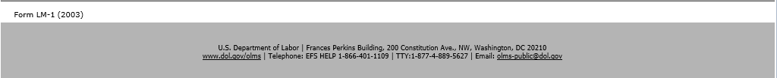

# Design

A mock-up design for ‘ITEM 10-17’ is displayed below.

# Requirements

The required fields are marked in the following screen mock-up.

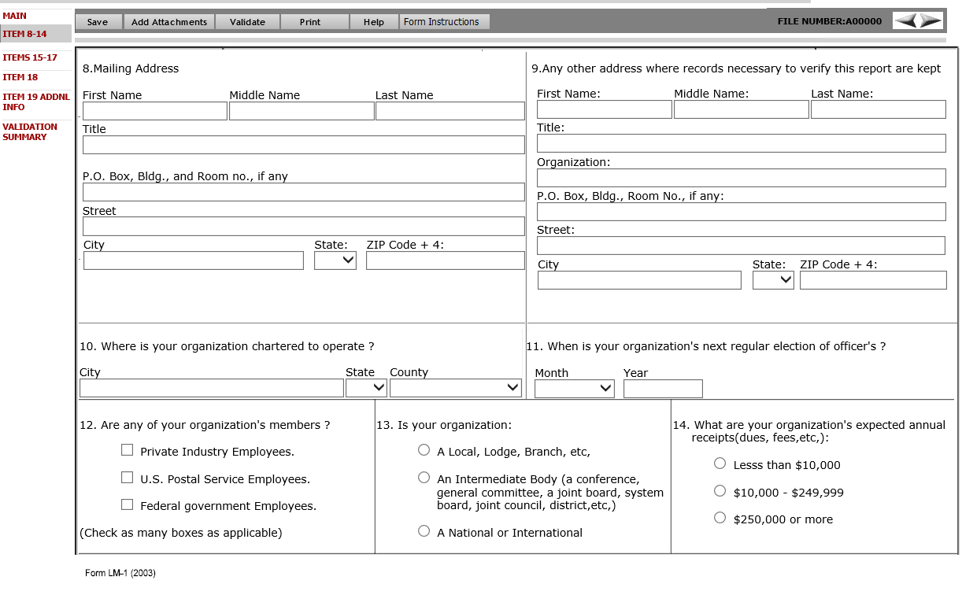

# Section/Field Level Requirements

The required fields are marked in the following screen mock-up

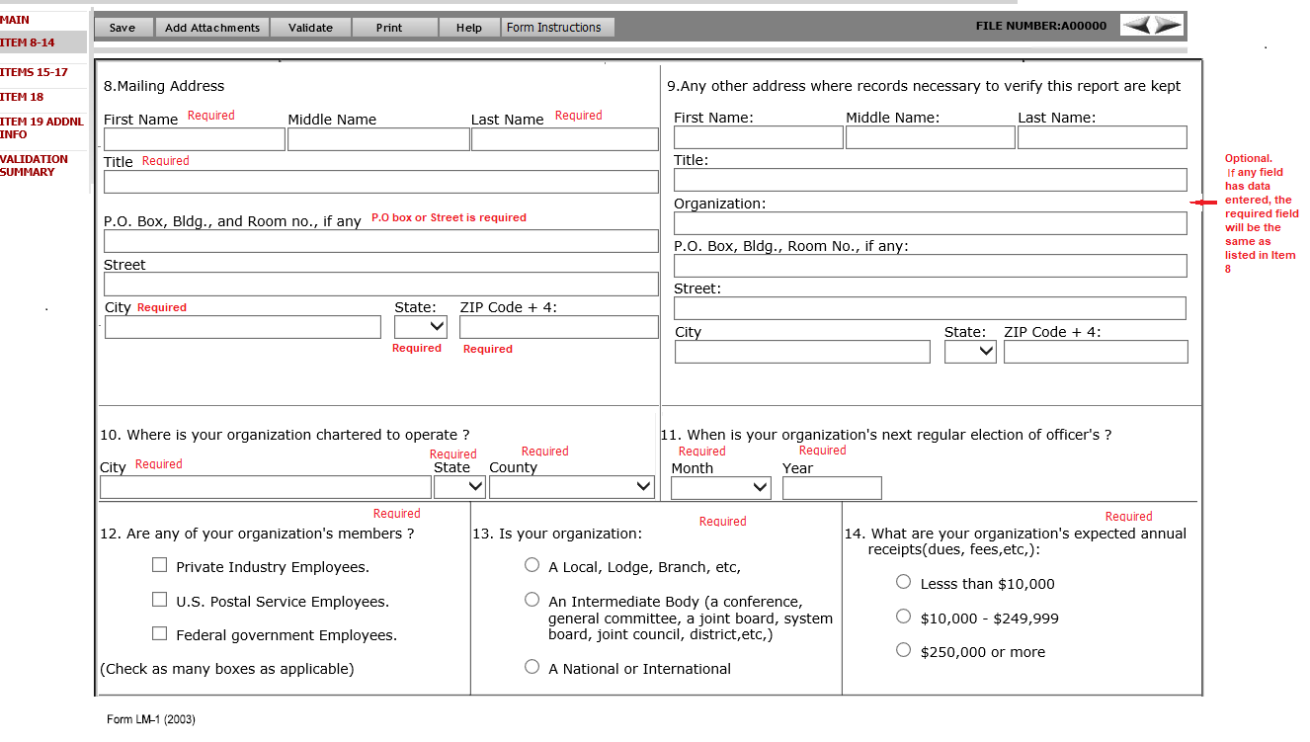

* **8. Mailing Address** - The following fields will be listed under this title
  + **First Name –** This will be a text field to enter the First Name of the individual to whom the mail should be directed.
  + **Middle Name -** This will be a text field to enter the Middle Name of the individual to whom the mail should be directed.
  + **Last Name -** This will be a text field to enter the Last Name of the individual to whom the mail should be directed.
  + **Title** – This will be a text field to enter the title of the individual.
  + **P.O. Box, Bldg., Room No., if any** - This will be a text field to enter the P.O Box or Building/room number.
  + **Street** - This will be a text field to enter the street address which the mail should be directed.
  + **City**- This will be a text field to enter the name of the City.
  + **State** - This will be a drop-down field to enter the State. The drop-down must list of all states code plus '00' for a non-state.
  + **Zip Code +4** – This will be a text field in 5 +4 format (xxxxx-xxxx).

When “00” selected as state, the Zip Code should accept the text in any format.

* **9. Any other address where records necessary to verify this report are kept:** - The following fields will be listed under this title
  + **First Name** – This will be a text field to enter the First Name of the individual.
  + **Middle Name** - This will be a text field to enter the Middle Name of the individual.
  + **Last Name** - This will be a text field to enter the Last Name of the individual.
  + **Title** – This will be a text field to enter the title of the individual.
  + **Organization** – This will be a text field to enter the name of the organization.
  + **P.O. Box, Bldg., Room No., if any** - This will be a text field to enter the P.O Box or Building/room number.
  + **Street** - This will be a text field to enter the street address which the mail should be directed.
  + **City**- This will be a text field to enter the name of the City.
  + **State** - This will be a drop-down field to enter the State. The drop-down must list of all states code plus '00' for a non-state.
  + **Zip Code +4** – This will be a text field in 5 +4 format (xxxxx-xxxx).

When “00” selected as state, the Zip Code should accept the text in any format.

* **10. Where is your organization chartered to operate?** –Fields listed in this section and its requirements are described below:
* **City**- This will be a text field to enter the name of the City.
* **State** - This will be a drop-down field to enter the State. The dropdown will list all states' code plus '00' for a non-state.
* **County** – This drop-down will list all the US counties. The county list will get filtered, based on the **State** selected.
  + If **00** is selected in the **State** field, the **County** Field should be changed to a ***Text*** field to manually enter the county.
* **11. When is your organization’s next regular election of officers? -** Fields listed in this section and its requirements are described below:
  + **Month –** a drop-down field listing the months in MMM format.
  + **Year** – Integer field to enter the year in YYYY format.
* **12. Are any of your organization’s members:** - Fields listed in this section and its requirements are described below:
  + The following three options will be listed. Allowed to pick more than one item.
    - **Private Industry Employees**
    - **U.S Postal Service Employees**
    - **Federal Government Employees**
  + The following text will be listed under the above options.

*(Check as many boxes as applicable)*

* **13. Is your organization:** Fields listed in this section and its requirements are described below:
  + The following three options will be listed. Allowed to pick only one item listed.
    - **A Local, Lodge, Branch, etc.**
    - **An intermediate body (a conference, general committee, joint council, district, etc.)**
    - **A National or International**
* **14. What are your organization’s expected annual receipts (dues, fees, etc.):** Fields listed in this section and its requirements are described below:
  + The following three options will be listed. Allowed to pick only one item listed.
    - **Less than $10,000**
    - **$10,000- 249,999**
    - **$250,000 or more**

**Following requirements applied only the form LM-1 Amendment**

* **The Amendment LM-1 should not pre-fill the items 10-17.**
* **These fields must be blank on load.**
* **The filer may enter information into these items or leave it blank**
* **These fields are not required on the amendment form.**

# Page 3

# Business Requirements

ITEM 18 (Page 3) captures the page number and section or paragraph where each practice or procedure is described in your organization’s constitution and bylaws or other governing rules filed with OLMS.

# Functional Requirements

The system shall display ‘Page 3’ in the following scenarios.

* When the filer selects “>” (next)’ button on the ‘ITEMS 10-17’ page.
* When the filer selects the ‘ITEM 18’ link from the Left Navigation Panel.

# Header Section

The header section pictured below will be displayed on Page 2.



# Footer Section

The footer section pictured below will be displayed on Page 3.



# Design

A mock-up design for Page #3 is displayed below.

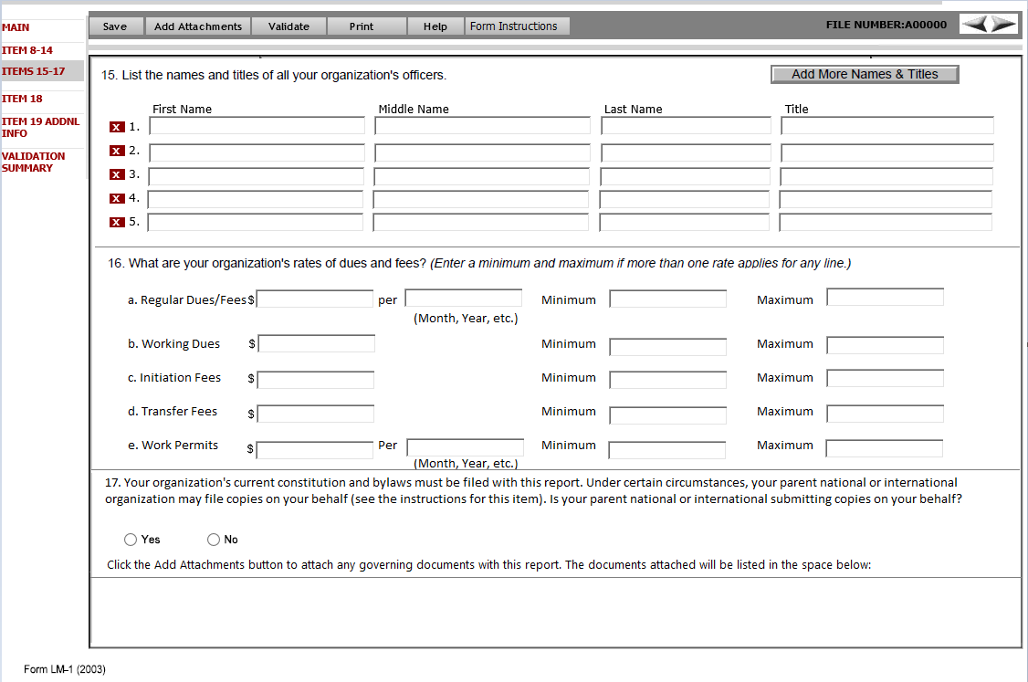

# Requirements

The required fields are marked in the following screen mock-up.

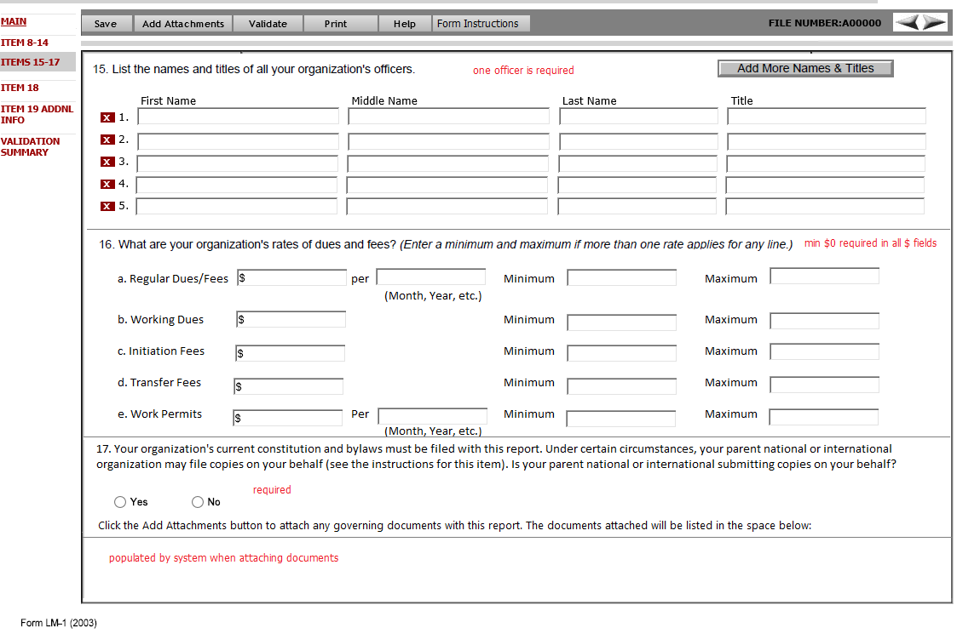

# Section/Field Level Requirements

* **15. List the names and titles of all your organization’s officers. –** Following fields in this section. Requirements for each field are described below:

This section will be listed as a grid line format. By default, the system should list five rows. Each row should have a delete (x) button to clear the data entered.

* + **First Name –** Text field to enter the first name of each officer.
  + **Middle Name –** Text field to enter the middle name of each officer.
  + **Last Name –** Text field to enter the last name of each officer.
  + **Title –** Text field to enter the titles of each officer.

Additional features in this section:

* + **Add More Names & Titles:** This button will be listed in this section. Clicking this button will add a new grid line to enter additional officers and their titles. The system will not limit the number of records that can be added.
  + Each line will have a delete button () to delete any line item.
* **16. What are your organization’s rates or dues and fees?** ***(Enter a minimum and maximum if more than one rate applies for any line.)*** *-* Fields listed in this section and its requirements are described below:
  + **a. Regular Dues/Fees** – This will be a VARCHAR field. The system will allow the user to enter an amount or a text in this field.
    - **Per** - Text field to enter the calendar basis for the payment. (e.g. month, year, etc.)
    - **Minimum** This will be a VARCHAR field. The system will allow the user to enter an amount or a text in this field.
    - **Maximum** *–* This will be a VARCHAR field. The system will allow the user to enter an amount or a text in this field.
  + **b. Working Dues** - This will be a VARCHAR field. The system will allow the user to enter an amount or a text in this field.
    - **Minimum** *–* This will be a VARCHAR field. The system will allow the user to enter an amount or a text in this field.
    - **Maximum** *–* This will be a VARCHAR field. The system will allow the user to enter an amount or a text in this field.
  + **c. Initiation Fees** - This will be a VARCHAR field. The system will allow the user to enter an amount or a text in this field.
    - **Minimum** *–* This will be a VARCHAR field. The system will allow the user to enter an amount or a text in this field.
    - **Maximum** *–* This will be a VARCHAR field. The system will allow the user to enter an amount or a text in this field.
  + **d. Transfer Fees** - This will be a VARCHAR field. The system will allow the user to enter an amount or a text in this field.
    - **Minimum** *–* This will be a VARCHAR field. The system will allow the user to enter an amount or a text in this field.
    - **Maximum** *–* This will be a VARCHAR field. The system will allow the user to enter an amount or a text in this field.
  + **e. Work Permits** - This will be a VARCHAR field. The system will allow the user to enter an amount or a text in this field.
    - **Per** - Text field to enter the calendar basis for the payment. (e.g. month, year, etc.)
    - **Minimum** *–* This will be a VARCHAR field. The system will allow the user to enter an amount or a text in this field.
    - **Maximum** *–* This will be a VARCHAR field. The system will allow the user to enter an amount or a text in this field.
* **17. Your organization's current constitution and bylaws must be filed with this report. Under certain circumstances, your parent national or international organization may file copies on your behalf (see the instructions for this item). Is your parent national or international submitting copies on your behalf?** – This is a **Yes** and **No** options field.
  + if **Yes** is checked and if **Affiliated** option is selected in Item 4,
    - The system will list a pop-up listing National Headquarters’ (NHQ) details.

**Your parent national organization, <Organization name selected in Item 4> has filed a constitution and bylaws on your behalf.**

* + if **No** is checked, the system should display the following pop-up message to the filer.
* If you selected “No”, you should attach and submit the governing documents with the completed Form LM-1 report. If your organization does not yet have governing documents, you must submit them with an amended Form LM-1 report. The documents you attach to this report will be listed in the space below Item 17.

This field will have an additional section below to list the attachments submitted with the report. The title for this section is listed below:

**Click the Add Attachments button to attach any governing documents with this report. The documents attached will be listed in the space below:**

This section will be disabled for data entry. When the filer attaches a file, the name of the file attached will be listed in this section. If no files attached, the section will be empty.

# Page 4

# Business Requirements

ITEM 18 (Page 3) captures the page number and section or paragraph where each practice or procedure is described in your organization’s constitution and bylaws or other governing rules filed with OLMS.

# Functional Requirements

The system shall display ‘Page 3’ in the following scenarios.

* When the filer selects “>” (next)’ button on the ‘ITEMS 10-17’ page.
* When the filer selects the ‘ITEM 18’ link from the Left Navigation Panel.

# Header Section

The header section pictured below will be displayed on Page 2.



# Footer Section

The footer section pictured below will be displayed on Page 3.



# Design

A mock-up design for Page #3 is displayed below.

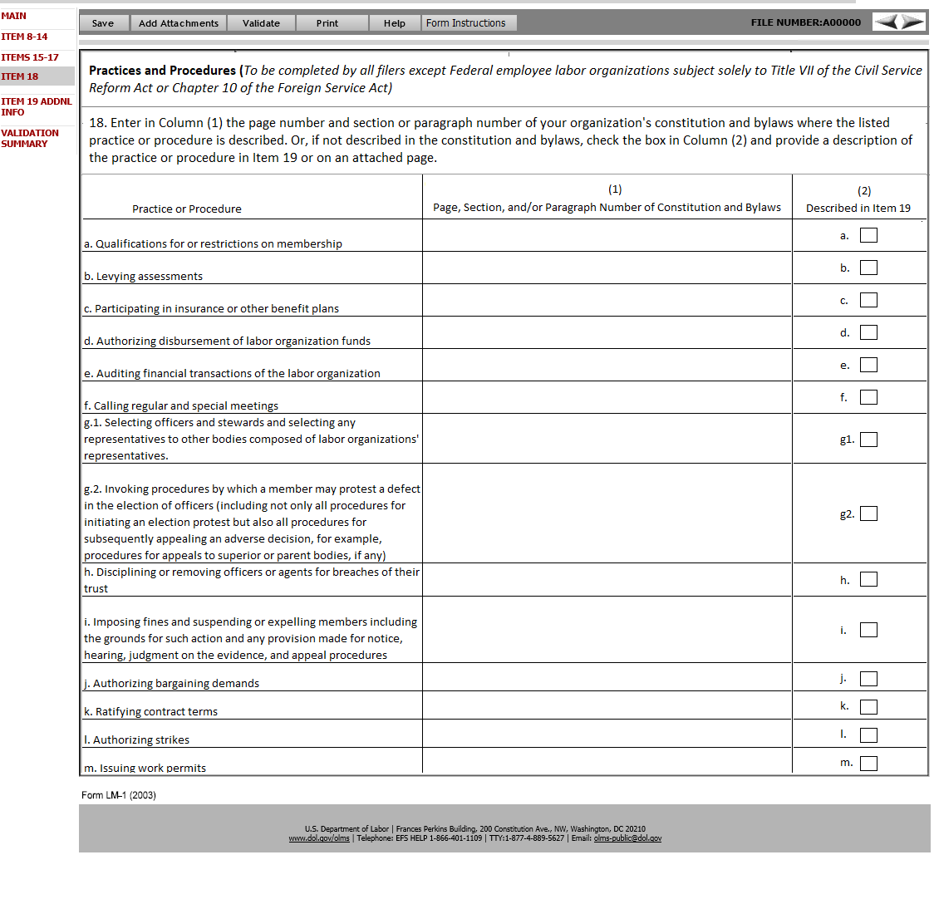

# Section/Field Level Requirements

The header section will list the following title.

**Practices and Procedures** (*To be completed by all filers except Federal employee labor organizations subject solely to Title VII of the Civil Service Reform Act or Chapter 10 of the Foreign Service Act*)

This page will list Item 18.

**18. Enter in Column (1) the page number and section or paragraph number of your organization's constitution and bylaws where the listed practice or procedure is described. Or, if not described in the constitution and bylaws, check the box in Column (2) and provide a description of the practice or procedure in Item 19 or on an attached page.**

Item will have the following three fields listed in a column format.

* + **Practice and Procedure**
  + **(1) Page, Section, and/or Paragraph Number of Constitution and Bylaws**
  + **(2) Described in Item 19**

The requirements for each column are listed below:

* **Practice and Procedure** – In this column the following questions (**a-m)** related to the practice and procedure will be listed.

**a. Qualifications for or restrictions on membership**

**b. Levying assessments**

**c. Participating in insurance or other benefit plans**

**d. Authorizing disbursement of labor organization funds**

**e. Auditing financial transactions of the labor organization**

**f. Calling regular and special meetings**

**g.1. Selecting officers and stewards and selecting any representatives to other bodies composed of labor organizations' representatives.**

**g.2. Invoking procedures by which a member may protest a defect in the election of officers (including not only all procedures for initiating an election protest but also all procedures for subsequently appealing an adverse decision, for example, procedures for appeals to superior or parent bodies, if any)**

**h. Disciplining or removing officers or agents for breaches of their trust**

**i. Imposing fines and suspending or expelling members including the grounds for such action and any provision made for notice, hearing, judgment on the evidence, and appeal procedures**

**j. Authorizing bargaining demands**

**k. Ratifying contract terms**

**l. Authorizing strikes**

**m. Issuing work permits**

* **(1) Page, Section, and/or Paragraph Number of Constitution and Bylaws** – This will be a text field to indicate the page number and section or paragraph where each practice or procedure listed in the “**Practice or Procedure**” column is described in the constitution and bylaws.
* **(2) Described in Item 19** – this will be a check-box field. Checking this box will open an ***Additional Information*** page. Each check-box will have a separate ***Additional Information page*** created. The data entered in each Additional Information page will be displayed in the **ITEM 19-ADDNL INFO** page.

# Page 5

# Business Requirements

Page 4 displays the additional information entered for each item listed on Page 3.

# Functional Requirements

The system shall display page 3 in the following scenarios.

• When the filer selects “>” (next)’ button on ITEM 18

• When the filer selects ITEM 19- ADDNL INFO link from Left Navigation Panel

• When the filer selects “<” (Previous)’ button on the Validation Summary

# Header Section

The header item pictured below will be displayed on Page 4.



# Footer Section

The footer item pictured below will be displayed on Page 4.



# Design

A mock-up design for **ITEM 19 – ADDNL INFO** page is pictured below:

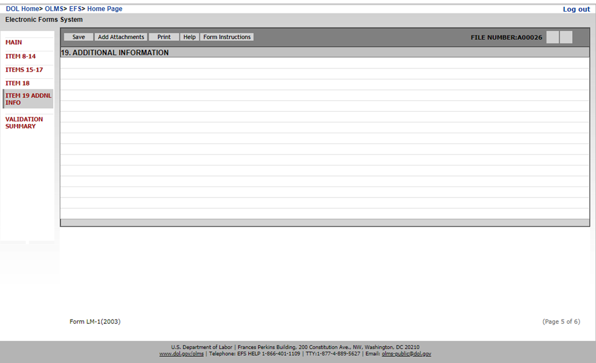

# Requirements

This page will list all additional information entered in the report. The page does not allow any data entry. The filers may enter additional information against multiple items listed on page 3. Additional information attached to each item will be listed in Item 19. Each item will be numbered using the same identifier as listed in Item 18.

**Title section** – The section should display the title **19. ADDITIONAL INFORMATION.**

The filer will use this page to review all the additional information entered in the report. Each listing will have navigation link enabled. Clicking the link will navigate the filer to the corresponding Item. The filer will go to the corresponding AI page to modify the text entered.

# Validation Summary Page

* The Validation summary page will list all errors, in the order of pages in the LM-1 form.
* Each error will have a Page number, Item number, Row number, and error message.
* A hyperlink will be provided along with each error. When the user selects this link the system will redirect the user to the page/ item that has an error.

# Other functionalities

The following functionalities are common to all the annual reports. LM-1 form will use the same architecture to perform these functionalities.

# Save

This button will save the current page and the data will be inserted to the EFS temporary database.

# Add Attachments

The filer will use the button to add any attachments that need to be submitted along with the LM-1 form.

# Validate

This button will all the pages, except the Main page performs the following.

1. Saves the page data to the EFS temporary database

2. Trigger a page-level validation and returns any error to be corrected. (Refer the validation summary document for the validation error for each field.)

# Print

This button will generate a print preview of the form. The format for the print preview should be closely matched with the approved report format.

# Help

This button will open the EFS Help page in a new tab.

# Form Instructions

This button will open the instructions page in a new tab. DIS will provide the HTML version of the LM-1 instructions.

# Submit

* The LM-1 form can be submitted only after the filer successfully signed the form.
* To submit the form, the filer will click the **Submit** button.
* Upon successful submission, the following confirmation message will be displayed.

# EFS Submission Confirmation Message

Your Form LM-1 has been successfully accepted for processing.

Your confirmation number is: <File Number>-<rpt_id>-<submission date time>.

Please make a note of this number for your records.

Your organization’s file number is <File Number generated upon successful submission> and unique Private Identification Number (PIN) is: <The same PIN generated initially with the registration ID>.

Please save the file number and the PIN for future reference. You will need to distribute this PIN to all users who access the OLMS EFS to prepare, sign, and/or file forms for your organization.

**What happens next?**

OLMS will review your LM-1. In the meantime, you may file your annual report using this file number and PIN. However, any report filed will appear on the OLMS Online Public Disclosure Room only once OLMS approves your LM-1.

OLMS Online Public Disclosure room link:

[**http://www.dol.gov/olms/regs/compliance/rrlo/lmrda.htm**](http://www.dol.gov/olms/regs/compliance/rrlo/lmrda.htm)

Mock-up listed below:

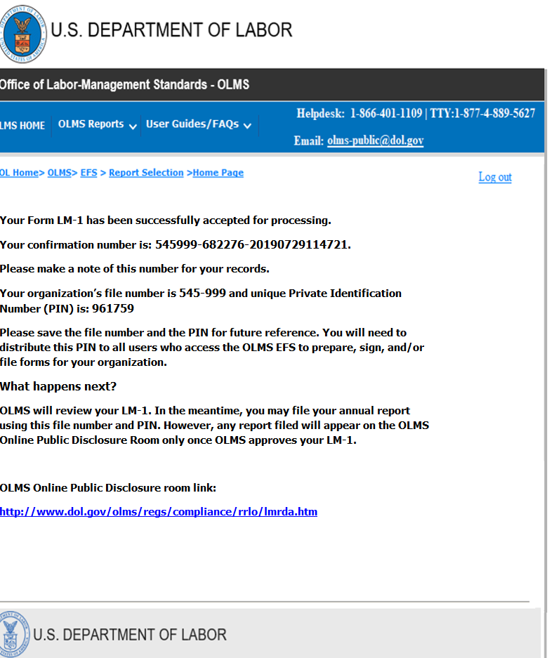

# Email Confirmation

Along with the confirmation message, the EFS system will send an email notification to all associated filers.

Subject line for the email: EFS LM-1 Submission Confirmation

 Thank you for completing the Form LM-1 and registering with the Office of Labor-Management Standards (OLMS).

 This email confirms your registration.

Your organization’s file number is <File Number generated upon successful submission> and unique Private Identification Number (PIN) is: <The same PIN generated initially with the registration ID>

**Note:** You have successfully submitted your Form LM-1 your **registration ID is no longer active**. Instead, in the future, use your File Number 545-999 and Private Identification Number (PIN) 708669.

Please save a copy of this email for future reference, as you will need to distribute this PIN to all users who access the EFS to prepare, sign, and/or file forms for your labor organization. To log into the EFS, all your users must enter this PIN, a valid user id and password, and the organization’s File Number.

You must renew your union PIN each year, as the current PIN will expire prior to the start of the next filing period.

 If you did not register this organization and believe you have received this email in error, please contact OLMS help desk at (866) 401-1109 or Email: [olms-public@dol.gov](mailto:olms-public@dol.gov).

**What happens next?**

OLMS will review your Form LM-1. In the meantime, you may file your annual report using this file number and PIN. However, any report filed will appear on the OLMS Online Public Disclosure Room only once OLMS approves your LM-1.

 OLMS Online Public Disclosure room link:

[**http://www.dol.gov/olms/regs/compliance/rrlo/lmrda.htm**](http://www.dol.gov/olms/regs/compliance/rrlo/lmrda.htm)

# Email generated to the OLMS approver’s team

Once the report is successfully submitted, the EFS system will generate an email to a new OLMS distribution group. The email will provide a summary of the LM-1 submitted and a link to approve the submitted report.

# Email text for an Affiliated or an Unaffiliated organization

Subject line: LM-1

A new LM-1 has been registered:

File Number: <File Number generated upon successful submission>

<Organization Name (Abbreviation)>

<Organization’s Designation and designation number>

Address

Click here to log in to EFS Admin.

A sample email is listed below:

**From:** [OLMS-EFS-NOTIFICATION@dol.gov](mailto:OLMS-EFS-NOTIFICATION@dol.gov) <[OLMS-EFS-NOTIFICATION@dol.gov](mailto:OLMS-EFS-NOTIFICATION@dol.gov)>  
**Sent:** Wednesday, July 03, 2019, 5:01 PM  
**To:** zzOLMS-NO-LM1-REGISTRATION <[zzOLMS-NO-LM1-REGISTRATION@dol.gov](mailto:zzOLMS-NO-LM1-REGISTRATION@dol.gov)>  
**Subject:** LM-1

|  |
| --- |
| **From:** [OLMS-EFS-NOTIFICATION@dol.gov](mailto:OLMS-EFS-NOTIFICATION@dol.gov) <[OLMS-EFS-NOTIFICATION@dol.gov](mailto:OLMS-EFS-NOTIFICATION@dol.gov)> **Sent:** Wednesday, July 03, 2019, 5:01 PM **To:** zzOLMS-NO-LM1-REGISTRATION <[zzOLMS-NO-LM1-REGISTRATION@dol.gov](mailto:zzOLMS-NO-LM1-REGISTRATION@dol.gov)> **Subject:** LM-1    A new LM-1 has been registered:  File Number: 545-998  Union of Law Enforcement Officers Security & Police(LEOS-PBA)  Local Union 21  Bethesda Local  123 Main St  Bethesda, MD 20817    Click here to log in to EFS Admin. |

# Email text for a National Organization

Subject line: LM-1 – New NHQ

A new affiliation has been created by <Organization Name (Abbreviation)>:

File Number: <File Number generated>

Address

Click here to approve this union.

A sample email is listed below:

From: OLMS-EFS-NOTIFICATION@dol.gov <OLMS-EFS-NOTIFICATION@dol.gov>  
Sent: Wednesday, July 03, 2019, 5:01 PM  
To: zzOLMS-NO-LM1-REGISTRATION <zzOLMS-NO-LM1-REGISTRATION@dol.gov>  
Subject: LM-1 – New NHQ

 A new NHQ has been created by the Union of Actuarial Workers (UOAW) :

File Number: 546-000

18411 Thundercloud Rd

Rockville, MD 20878

Click here to log in to EFS Admin.

Filers are allowed to use the new file number and PIN to submit their annual reports. Any report before the approval of LM-1 will not get disclosed on the OLMS disclosure site.

# Approval Process

Approval functionality will be added to the EFS Admin application. The requirements for the approval process is listed in the documents below:



# Approval Email Notifications to the filers

The email text is attached below:



# Disclosed Report

Once OLMS approves the LM-1 report, the reports will be disclosed on the OLMS disclosure site. The disclosed report must match with the OMB approved LM-1 form format. OMB approved form (PDF) linked below:

<https://www.dol.gov/olms/regs/compliance/GPEA_Forms/forms/Form_LM1_2021.pdf>

Approved Electronic LM-1 report will have hyperlink enabled to view the submitted report.

Until the union submits the annual report, the detail section will list the following message.

**“No Annual Reports to display.”**

The attachment section will list all attachments submitted, approved initial LM-1 report and all amended LM-1 reports. The LM-1 report will be listed in the following format in the ***Description*** and ***File Name*** column:

**<file number>-LM-1-<amendment #>.**

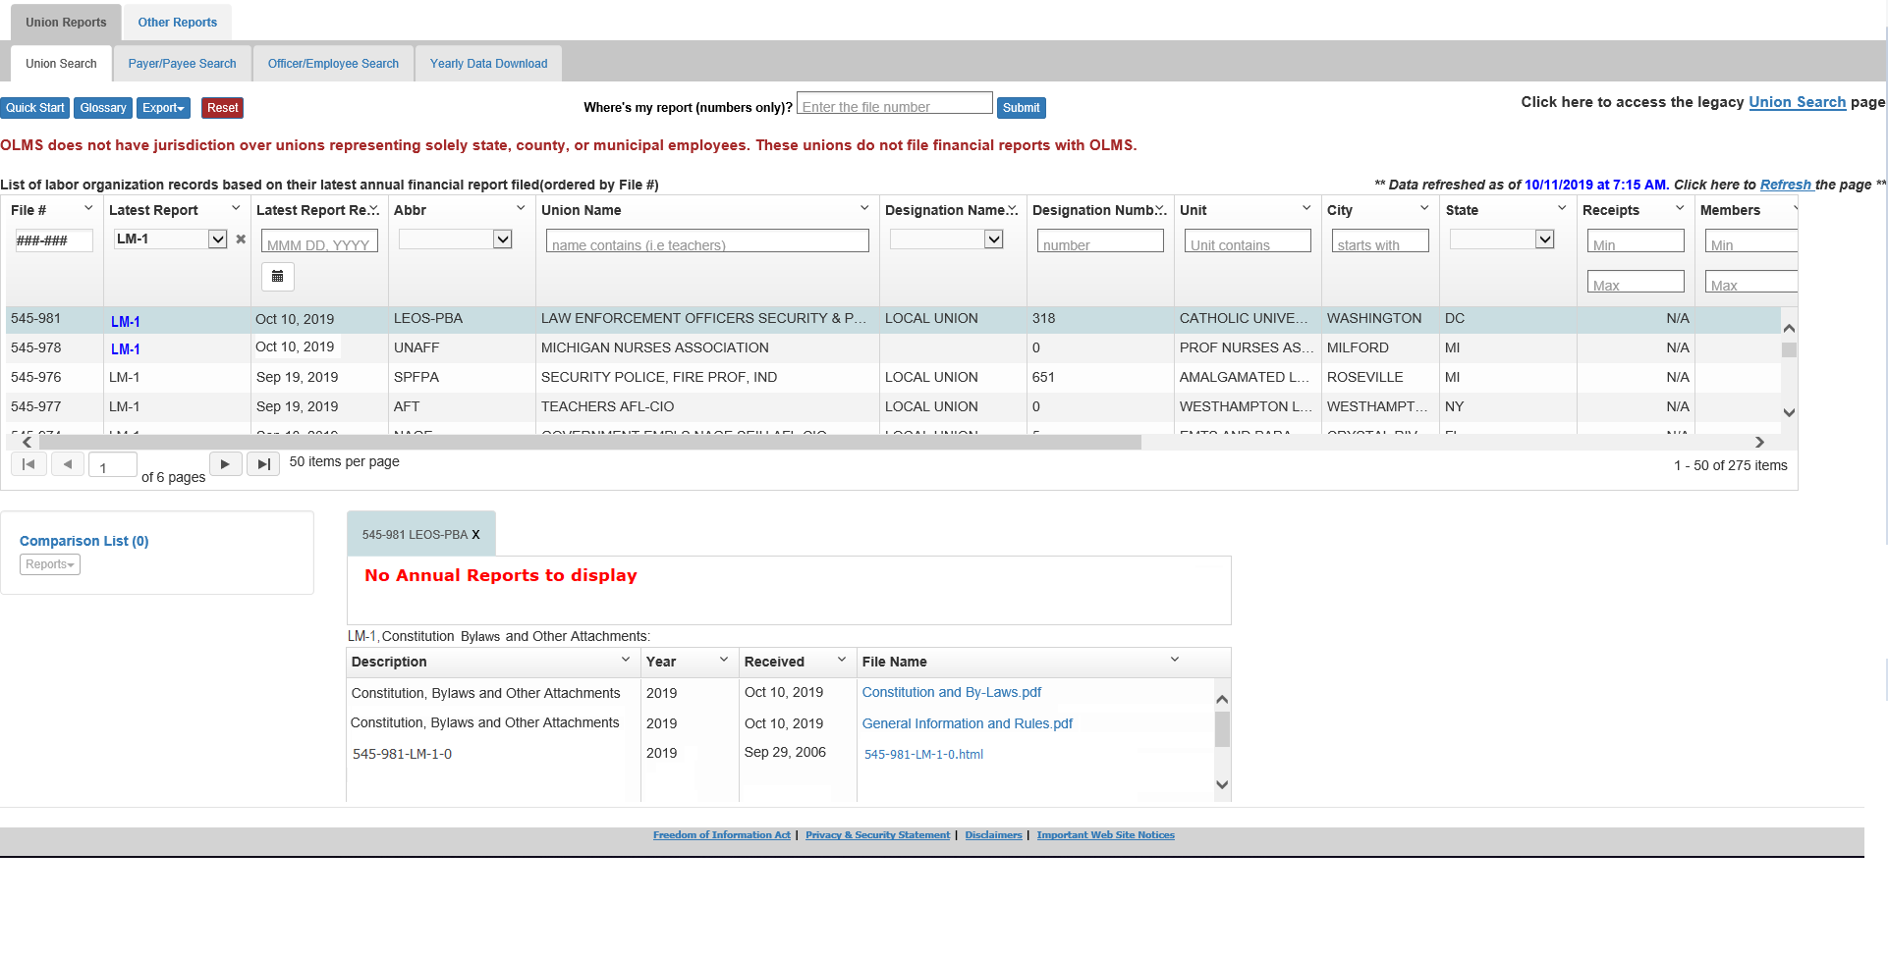

# Login using rejected LM-1

The union will not be allowed to use their file number in EFS once rejected. If the union tries to login, the EFS system will display the following message:

**The union number you entered not approved by OLMS. If you feel this is in error, please contact the OLMS help desk at (866) 401-1109.**

# Amend an LM-1 form

To amend an LM-1, the filer will have to log in using their permanent file number and the PIN. Upon successful login, the submitted LM-1 should be available for the filers to select. Once selected, the form will open listing the submitted data.

The following field-level requirements also listed under the corresponding page level requirements above.

* **1 –File number** –Will display the file number of the organization when amending an LM-1 and will remain read-only.
* **3.** **Is this the first From LM-1 your organization has field.** – Items listed in this section and the requirements are described below:
  + **No, this is an AMENDED FORM LM-1** – This will be a check-box field. This checkbox will be checked by the system when amending a submitted form and will remain as a read-only field.
* To submit an amendment, the filer will log in using the permanent file number and PIN.
* A union is allowed to amend any version of the LM-1 report submitted.

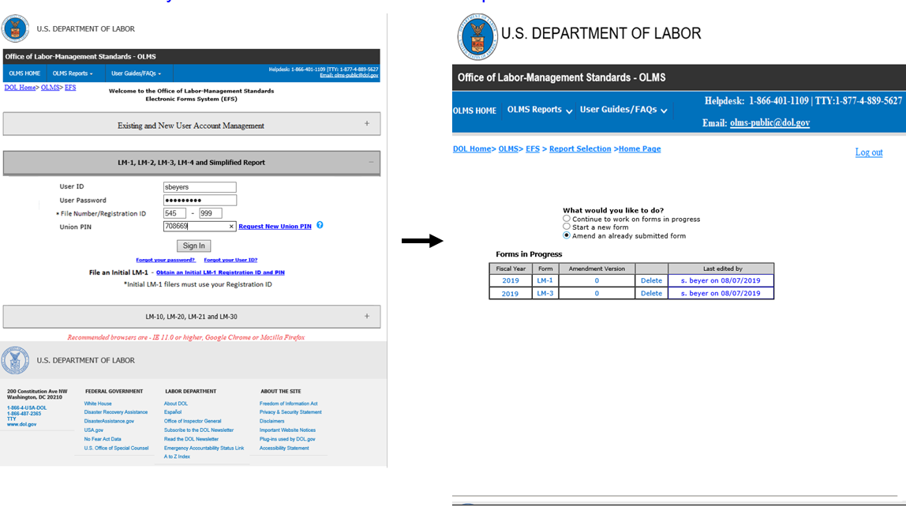

**Following field-level requirements applied only the form LM-1 Amendment**

* **The Amendment LM-1 should not pre-fill the item 10-17.**
* **These fields must be blank on load.**
* **The filer may enter information into these items or leave it blank**
* **These fields are not required on the amendment form.**

# Requirements Revisions History

Meeting minutes for the review meetings are listed below:

| **Date** | **Change Nature** | **Stakeholders Involved** | **Decision/Changes Provided** | **Comments** |
| --- | --- | --- | --- | --- |
| 06/27/2019 | Review meeting | Listed in the meeting minutes |  |  |
| 07/30/2019 | Review Meeting | Listed in the meeting minutes |  |  |
| 11/08/2019 | Review Meeting | Listed in the meeting minutes |  |  |